Nama = Hatta Efrizal

Nim = 09011282126041

Domain yang dicari yaitu

1. Google.com
2. Amazon.com
3. Facebook.com
4. Unsri.ac.id
5. Cyberacademy.id

1.Alamat Server domain google.com dengan command nslookup

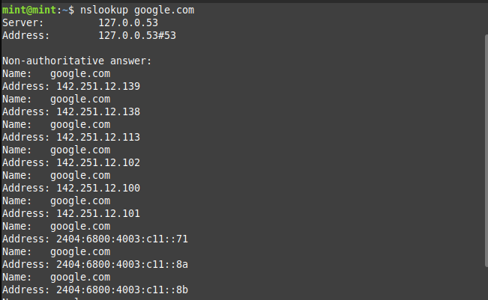

1.Command dig domain google.com

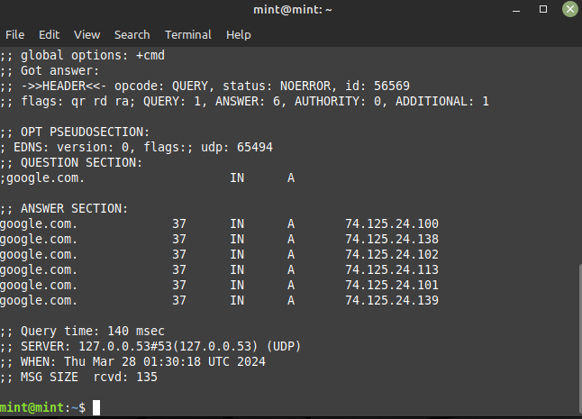

1.Command nmap domain google.com

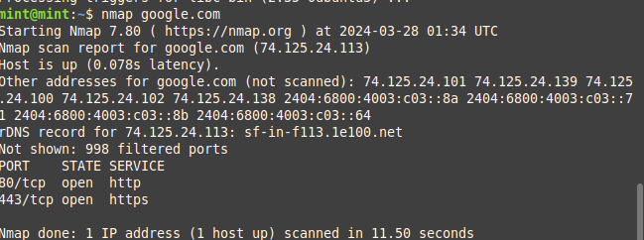

2.Commad nslookup domain amazon.com

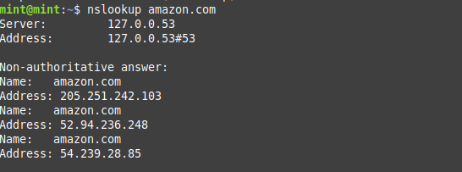

2.Commad dig domain amazon.com

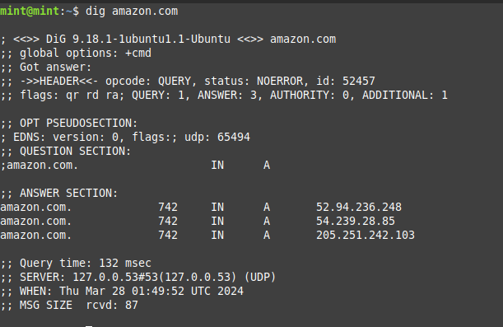

2.Commad nmap domain amazon.com

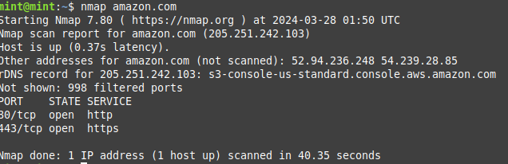

3.Commad nslookup domain facebook.com

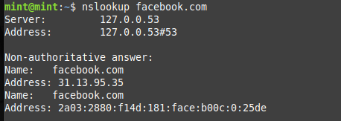

3.Commad dig domain facebook.com

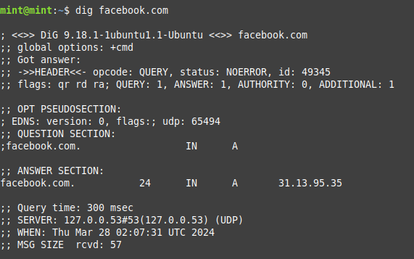

3.Commad nmap domain facebook.com

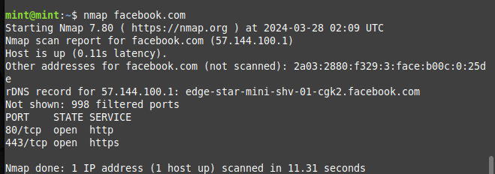

4.Commad nslookup domain unsri.ac.id

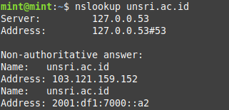

4.Commad dig domain unsri.ac.id

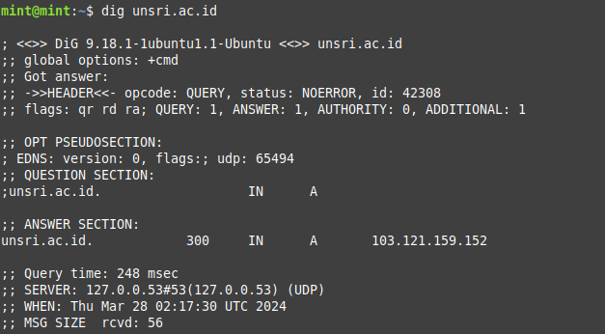

4.Commad nmap domain unsri.ac.id

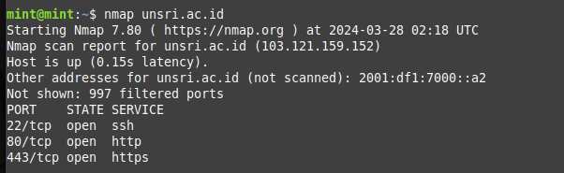

5.Commad nslookup domain cyberacademy.id

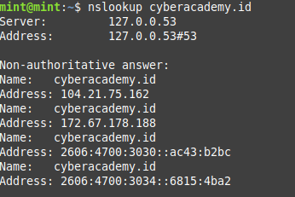

5.Commad dig domain cyberacademy.id

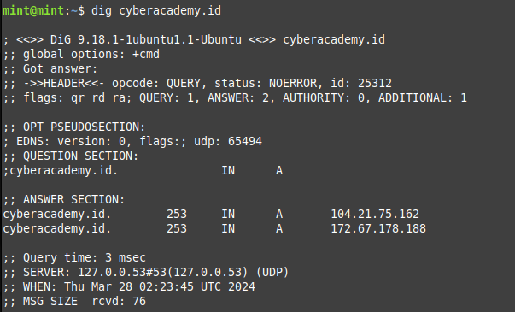

5.Commad nmap domain cyberacademy.id

